# SPRING BOOT

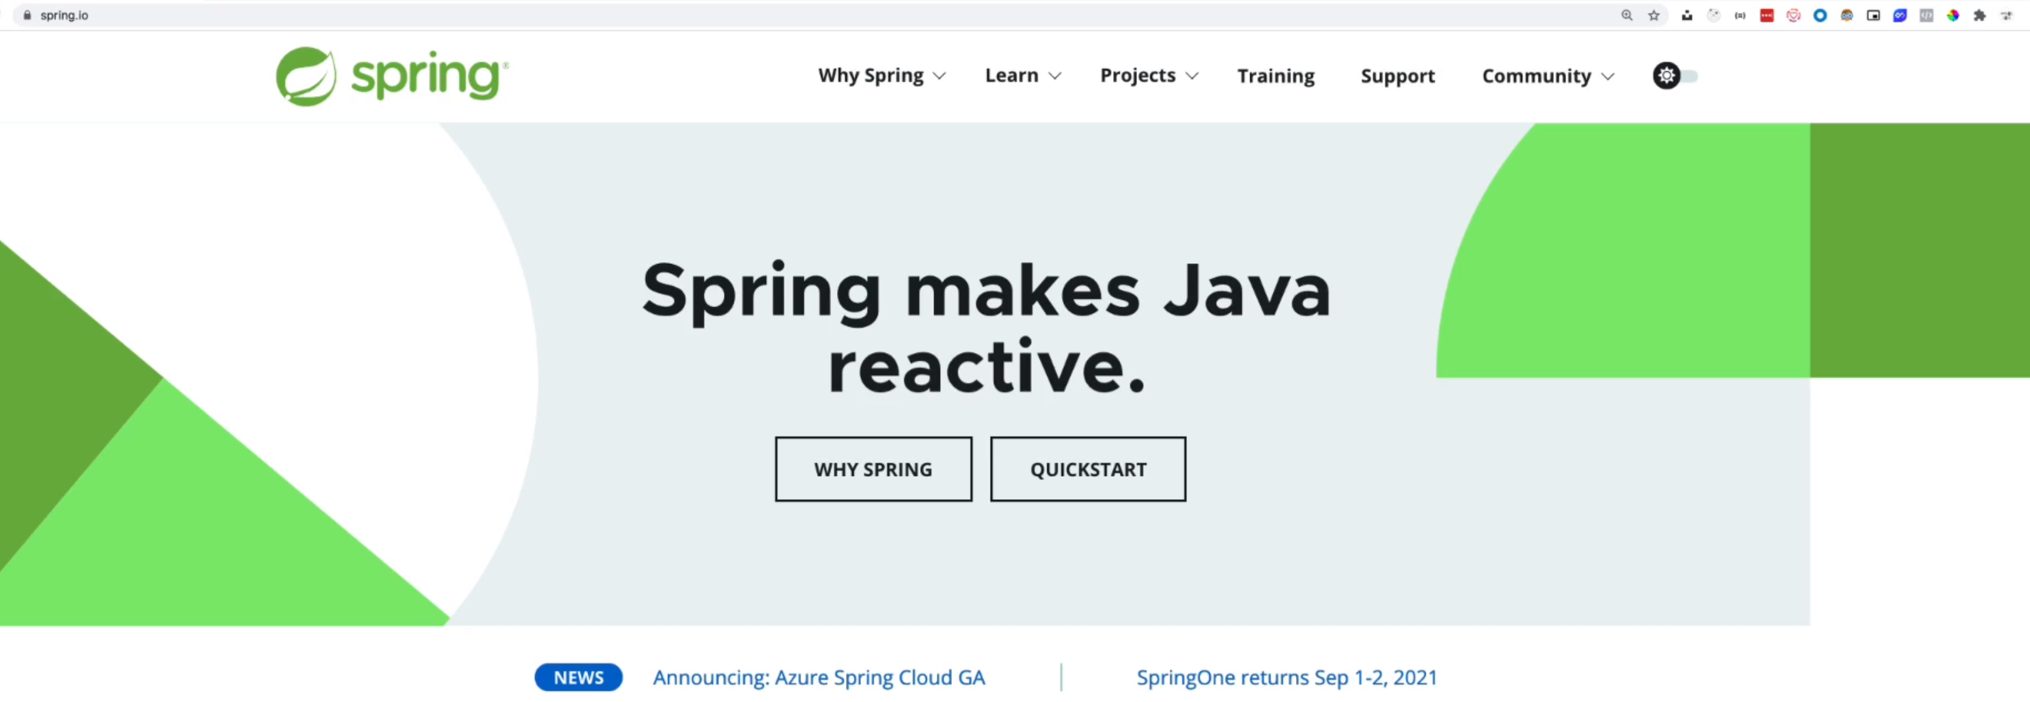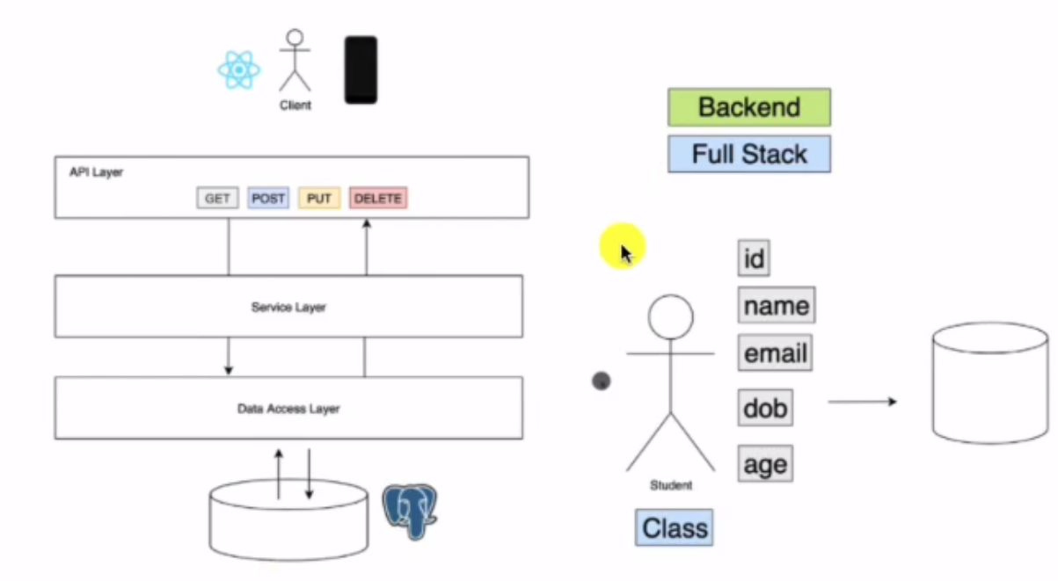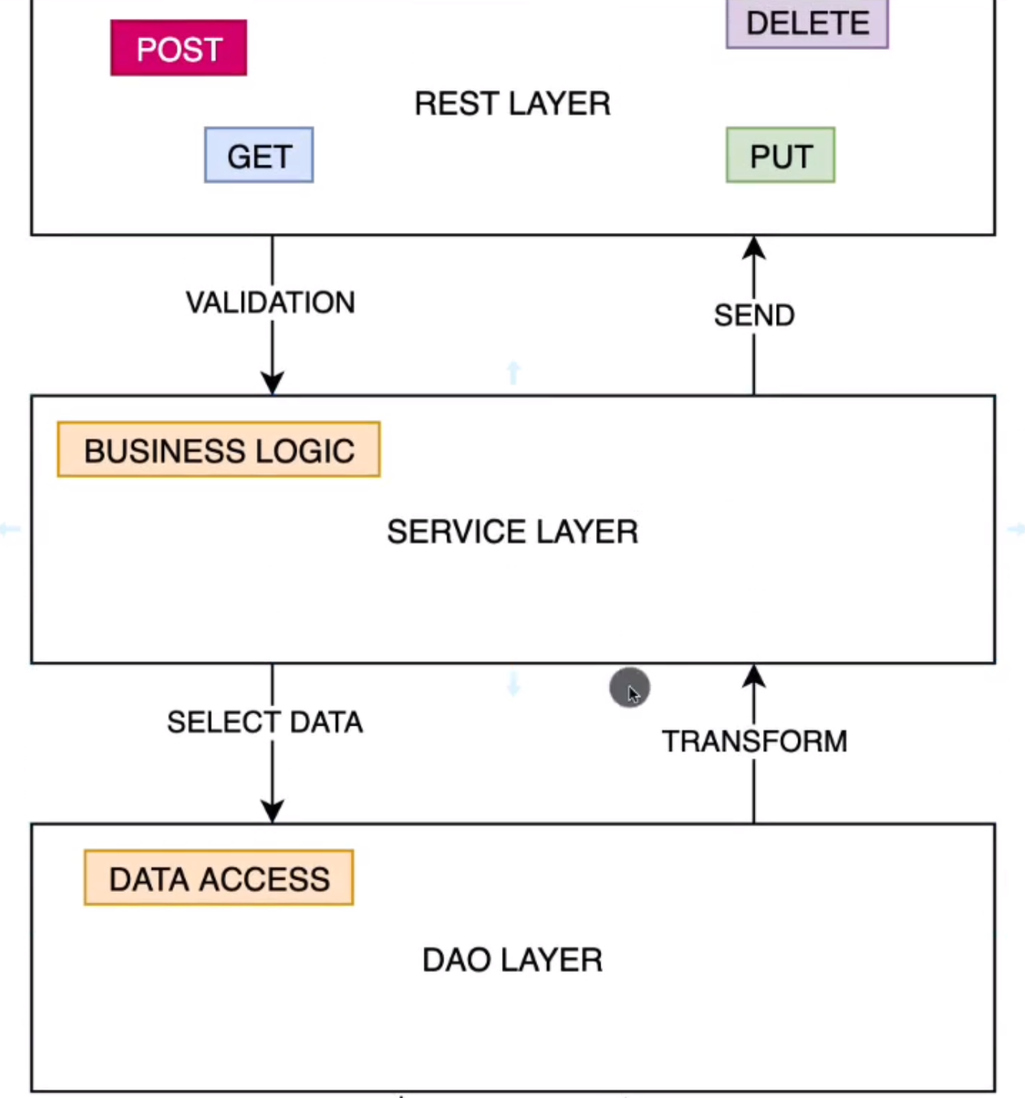

## Spring Boot devtools

<https://www.youtube.com/watch?v=BvIM9gNTDM4>

## Setting properties

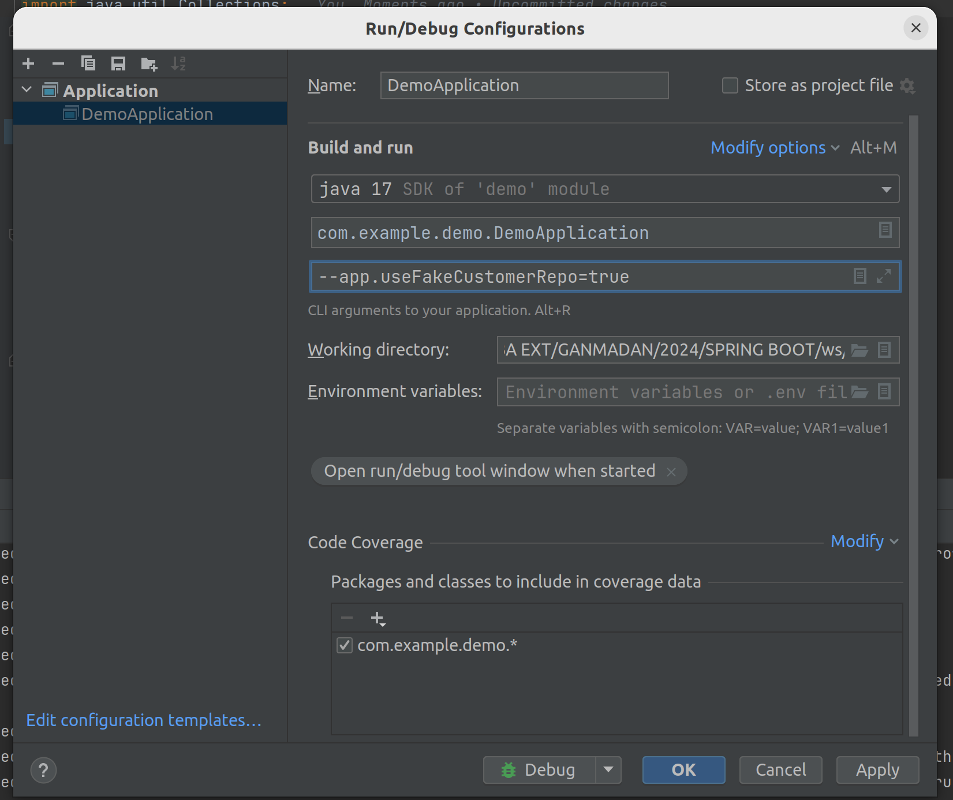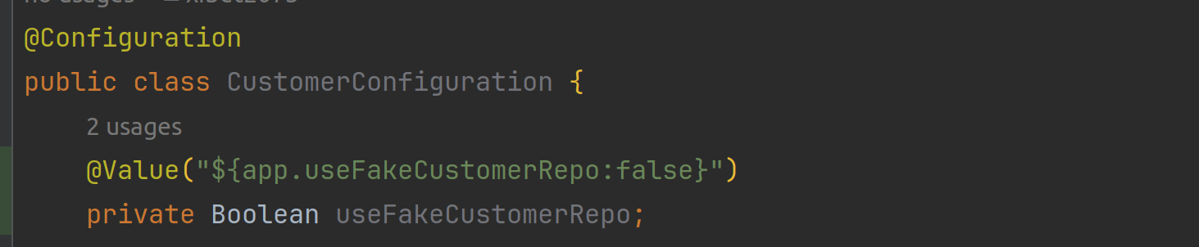

**:false** is a default value.

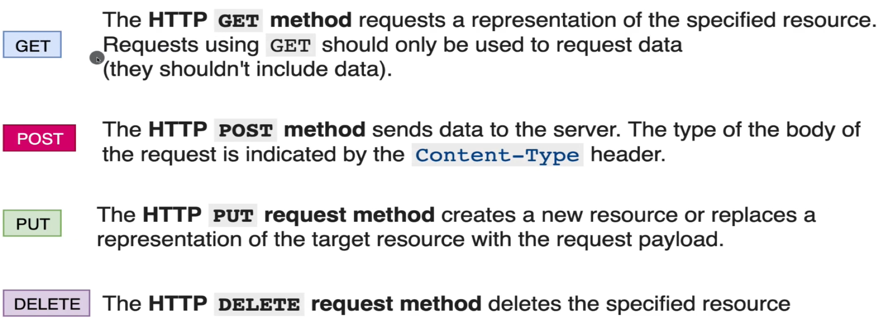

## Request body validation

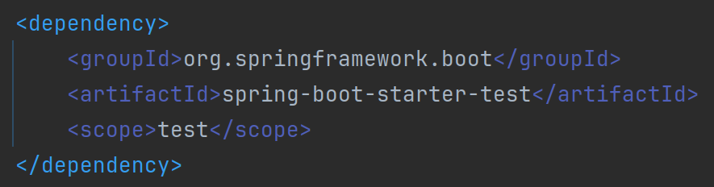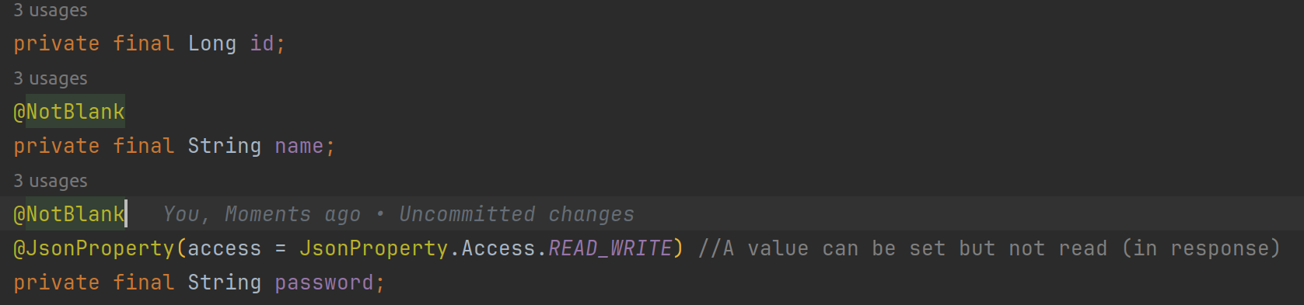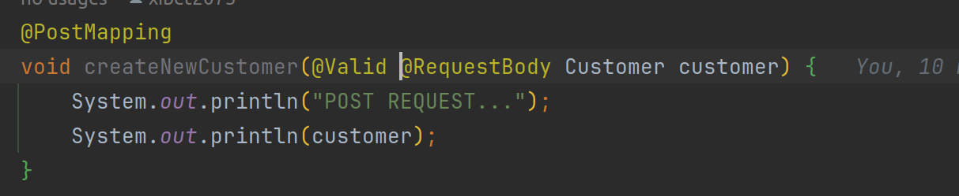

Errore che si verifica se vengono passati i campi non valorizzati.

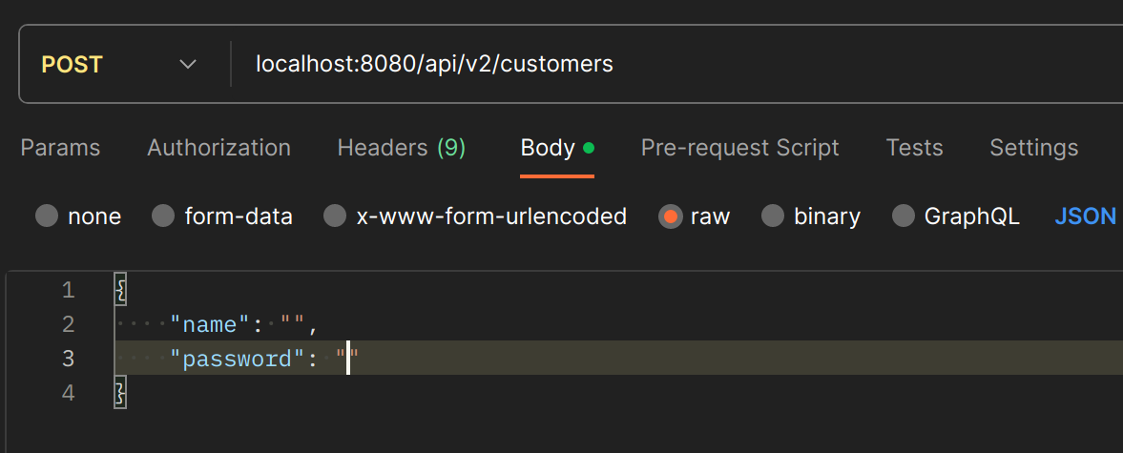

[Field error in object 'customer' on field 'password': rejected value [null]; codes [NotBlank.customer.password,NotBlank.password,NotBlank.java.lang.String,NotBlank];

## Exception handling

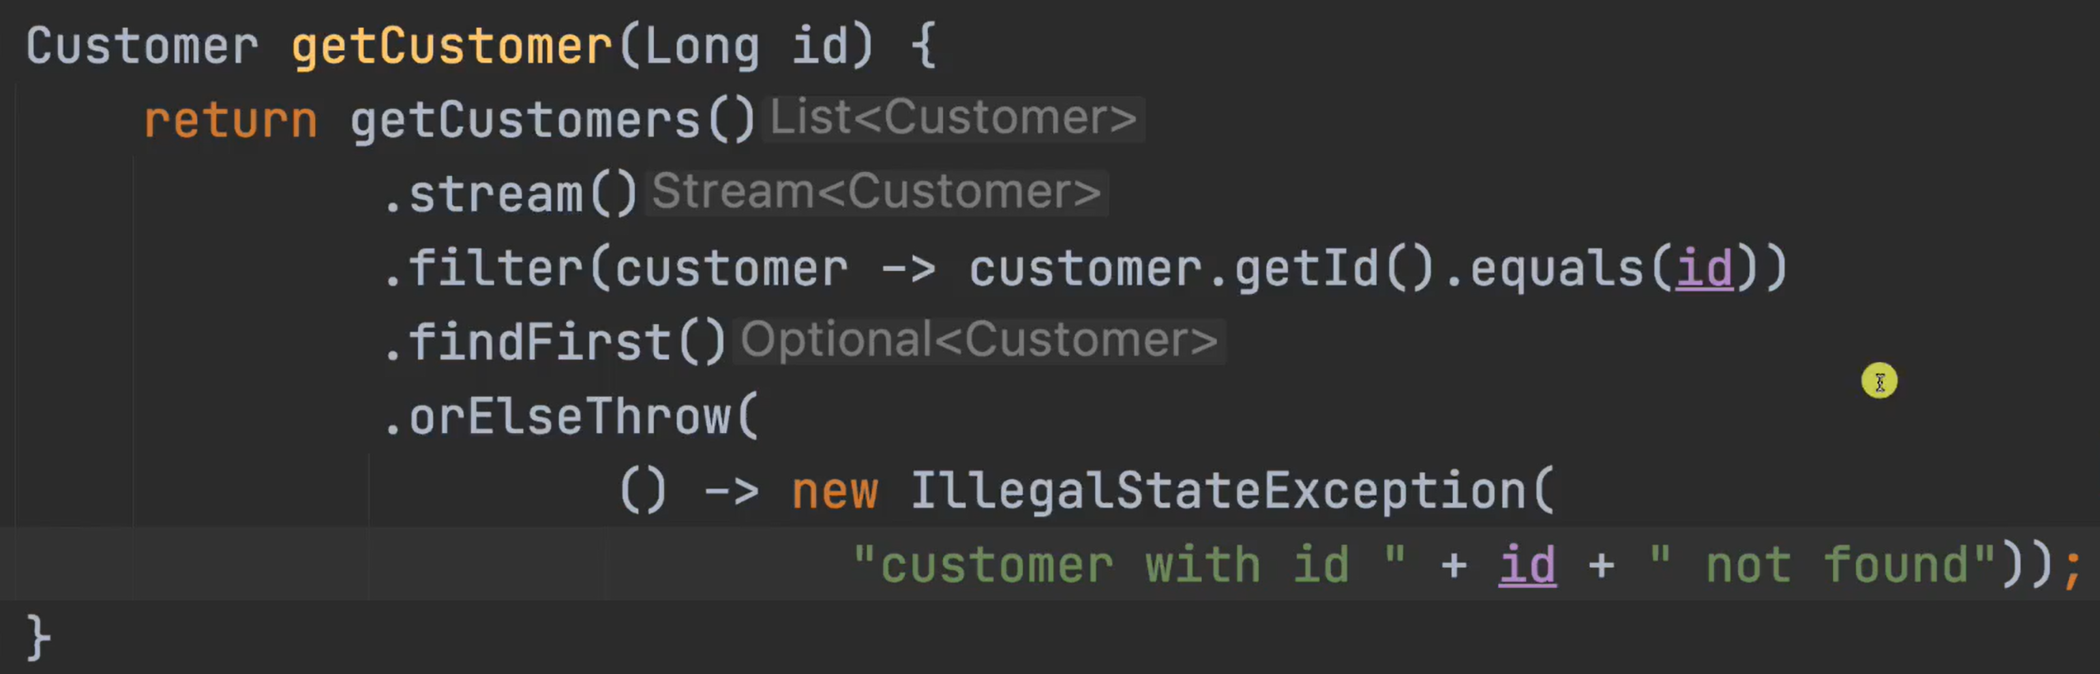

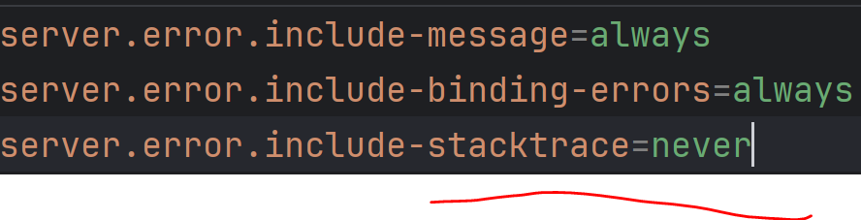

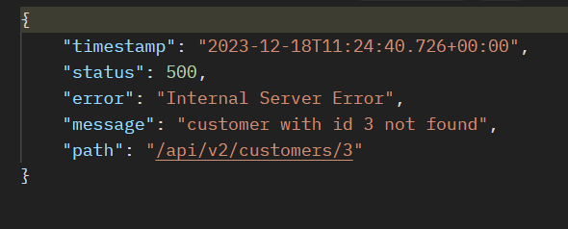

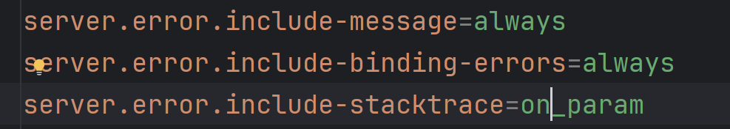

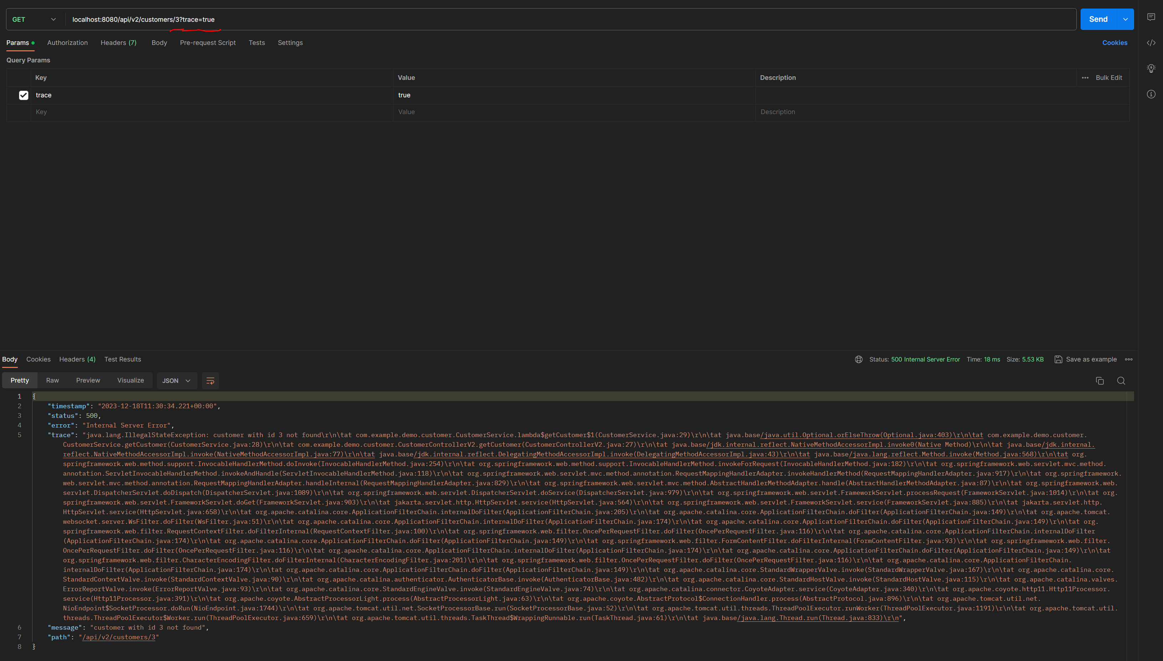

## Http response status codes

<https://developer.mozilla.org/en-US/docs/Web/HTTP/Status>

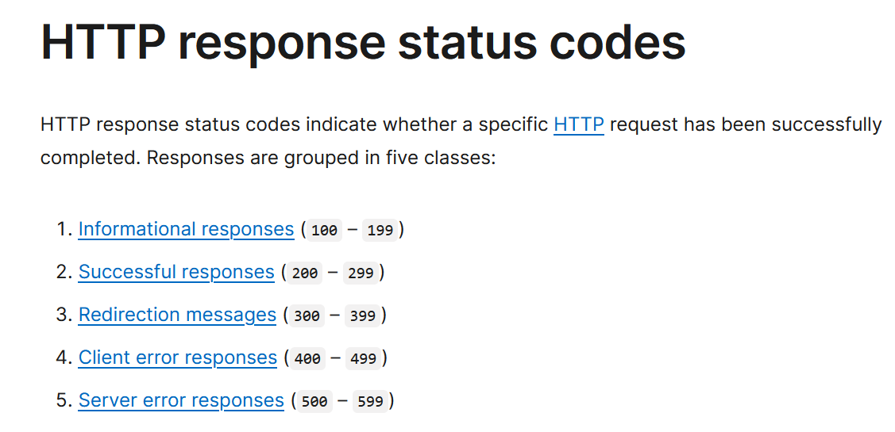

### Custom exception

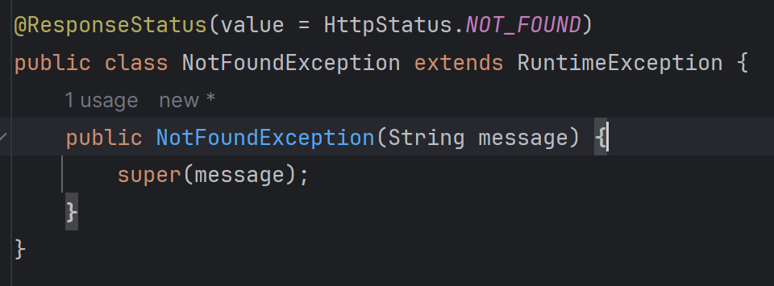

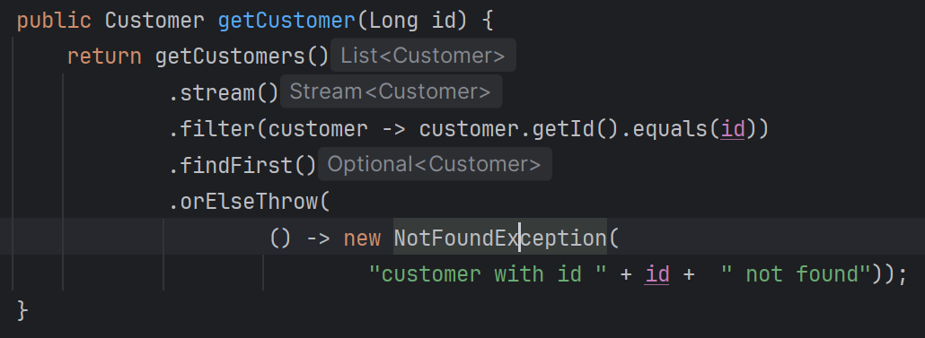

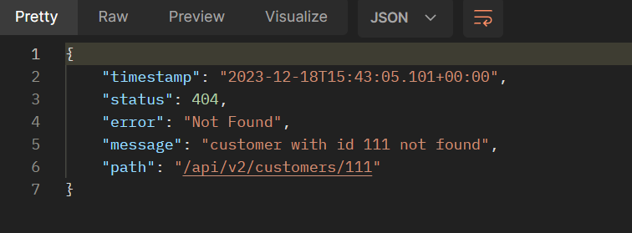

Spring Data   
<http://localhost:8080/h2>

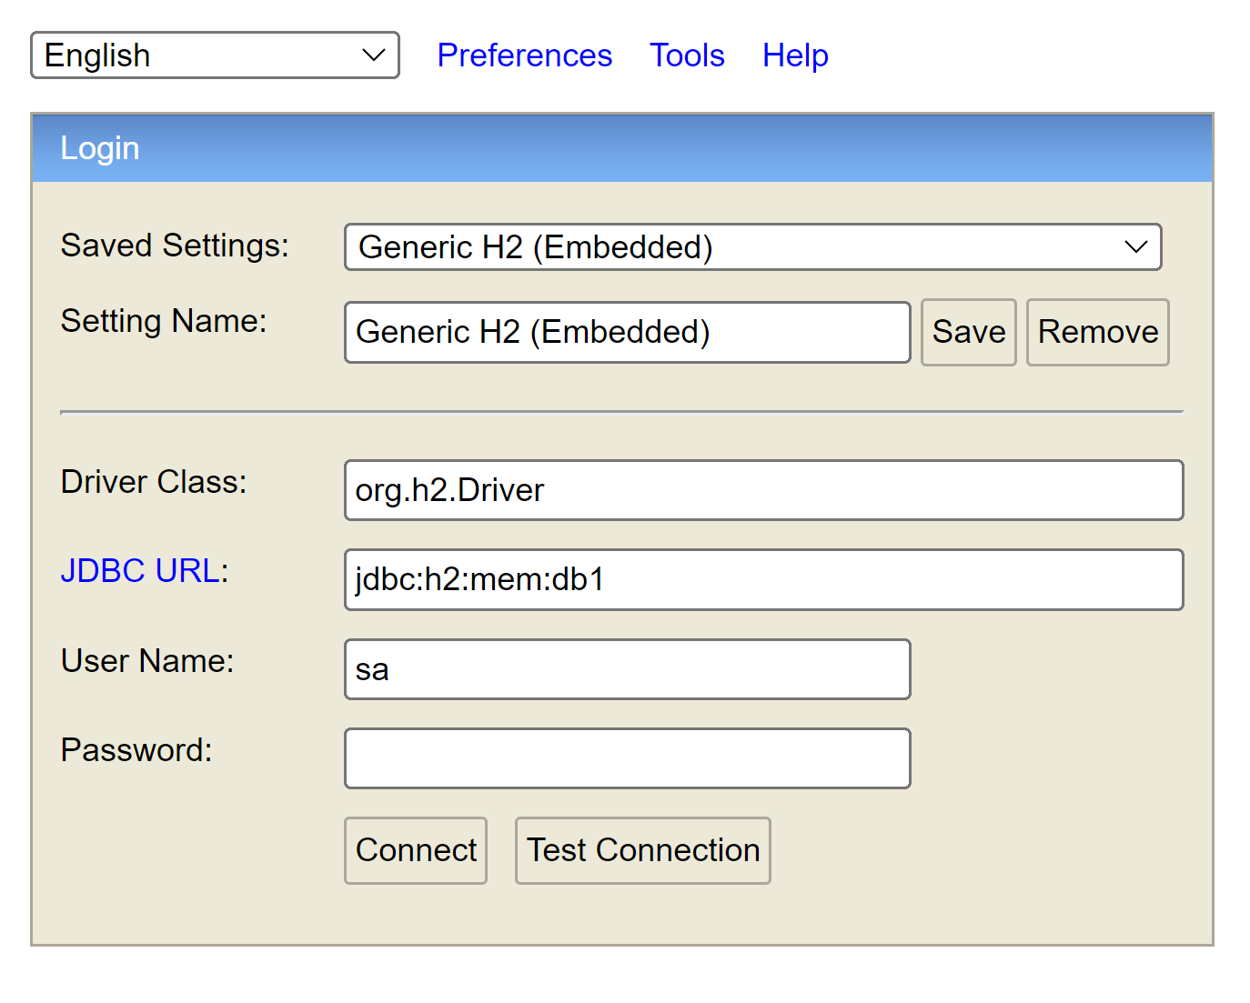

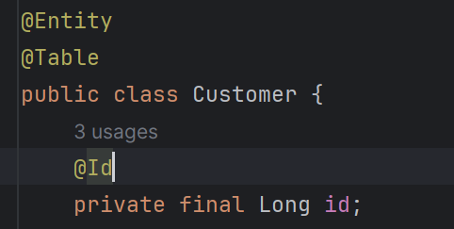

## Feign rest client

<https://github.com/OpenFeign/feign>  
<https://spring.io/projects/spring-cloud-openfeign>

## JSONPlaceholder

https://jsonplaceholder.typicode.com/

>>> 44